**DevOps Balachandran K K**

**22ISR005**

**Task 2**

Create a Jerkins pipeline job to automate the build and deployment of the HTML website from GitHub Repository using Ubuntu VM.

1. Files in GitHub.

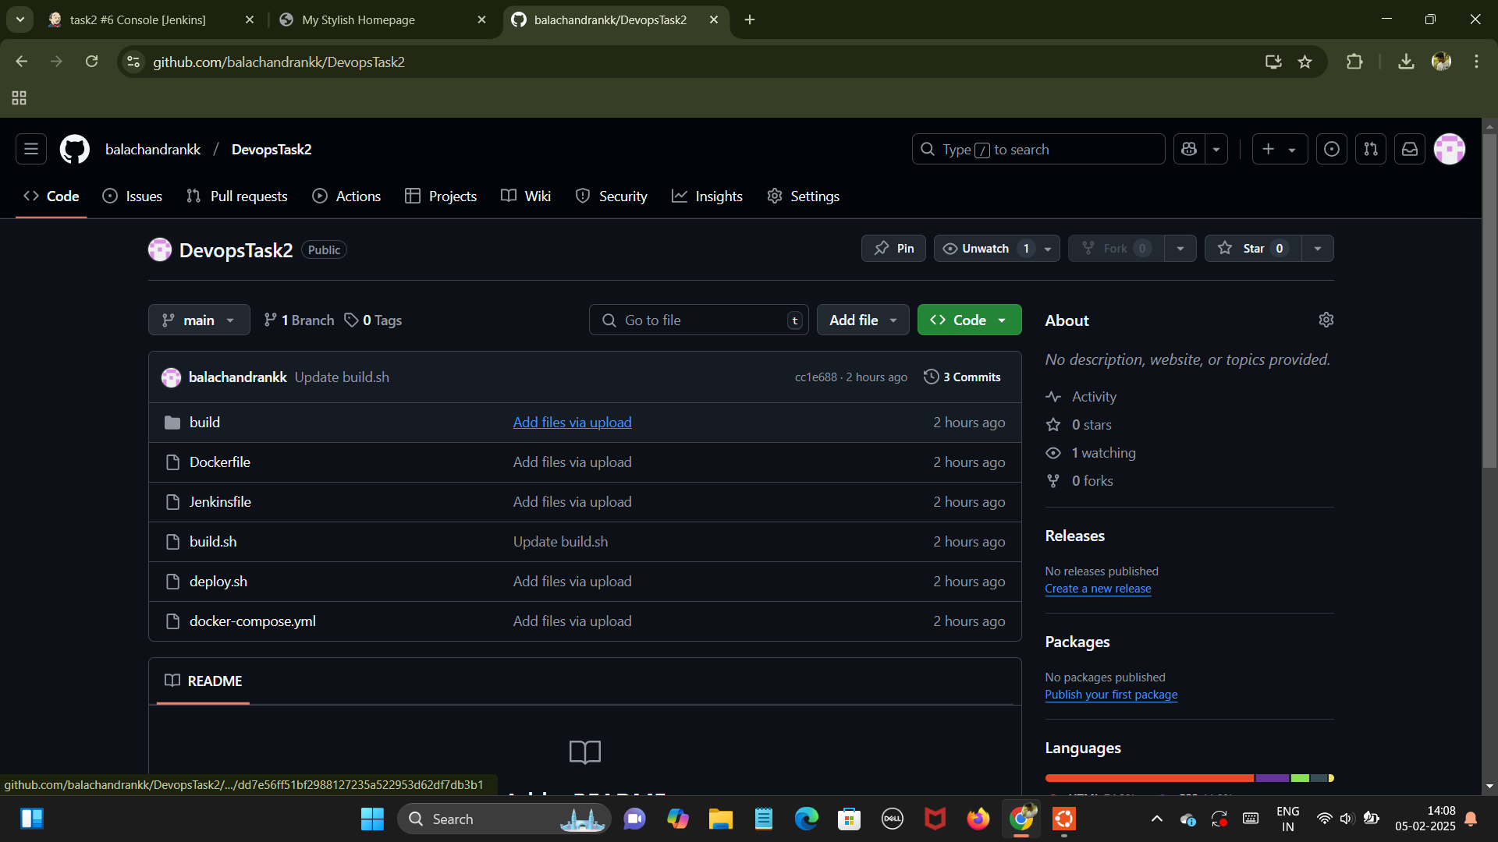

1. deploy.sh which consists of docker login and image details.

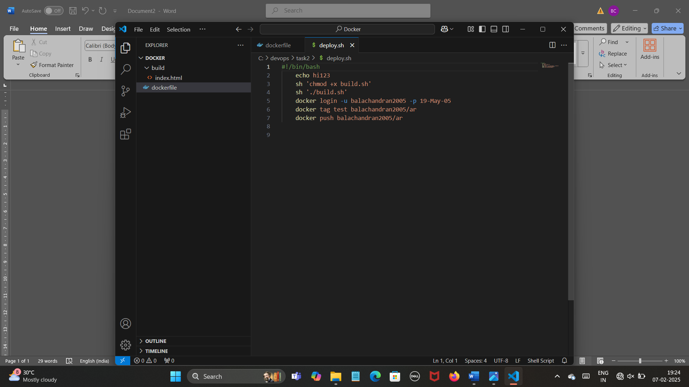

1. Connecting GitHub with Jenkins Pipeline.

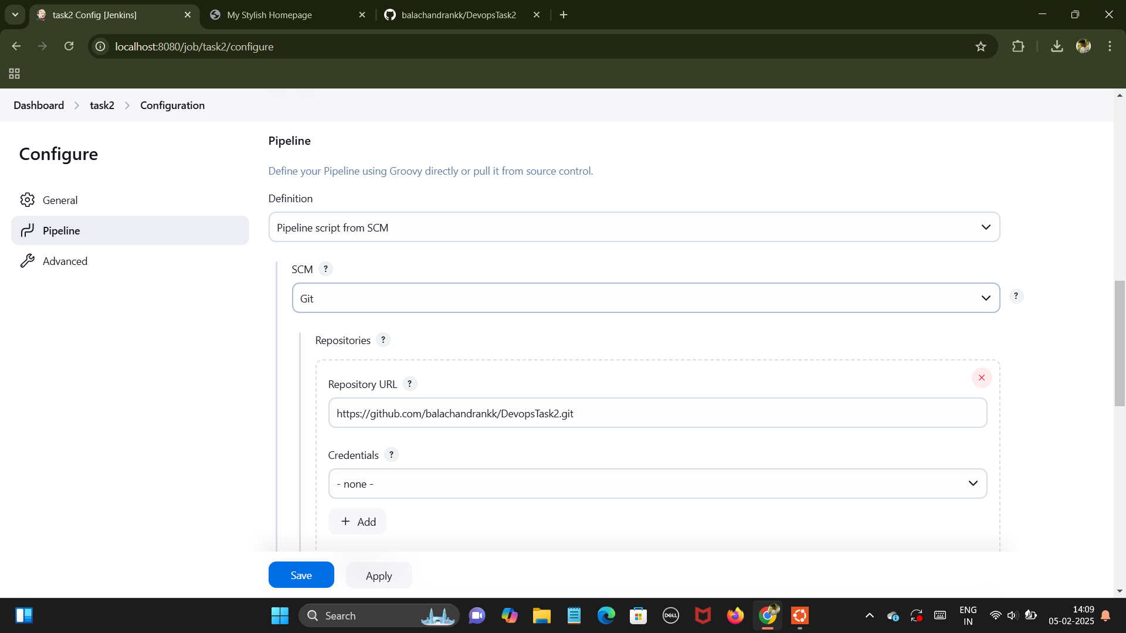

1. Permission command to get successful running.

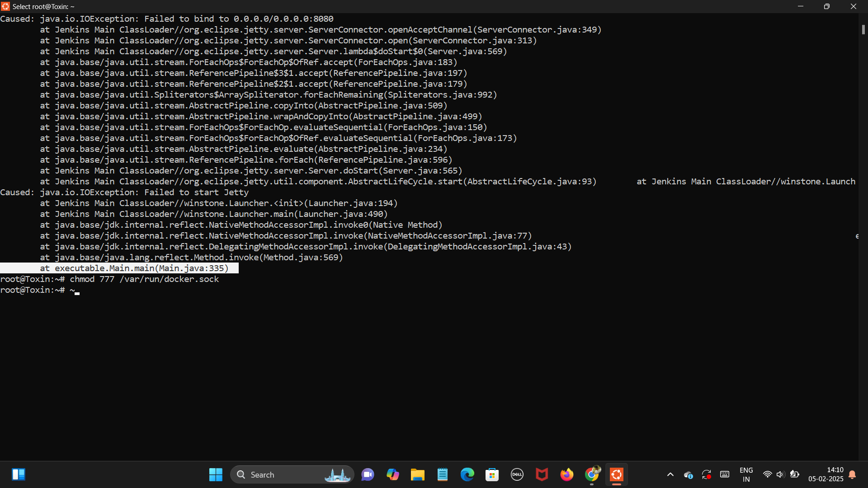

1. Console Output after Successful execution of Shell commands in GitHub.

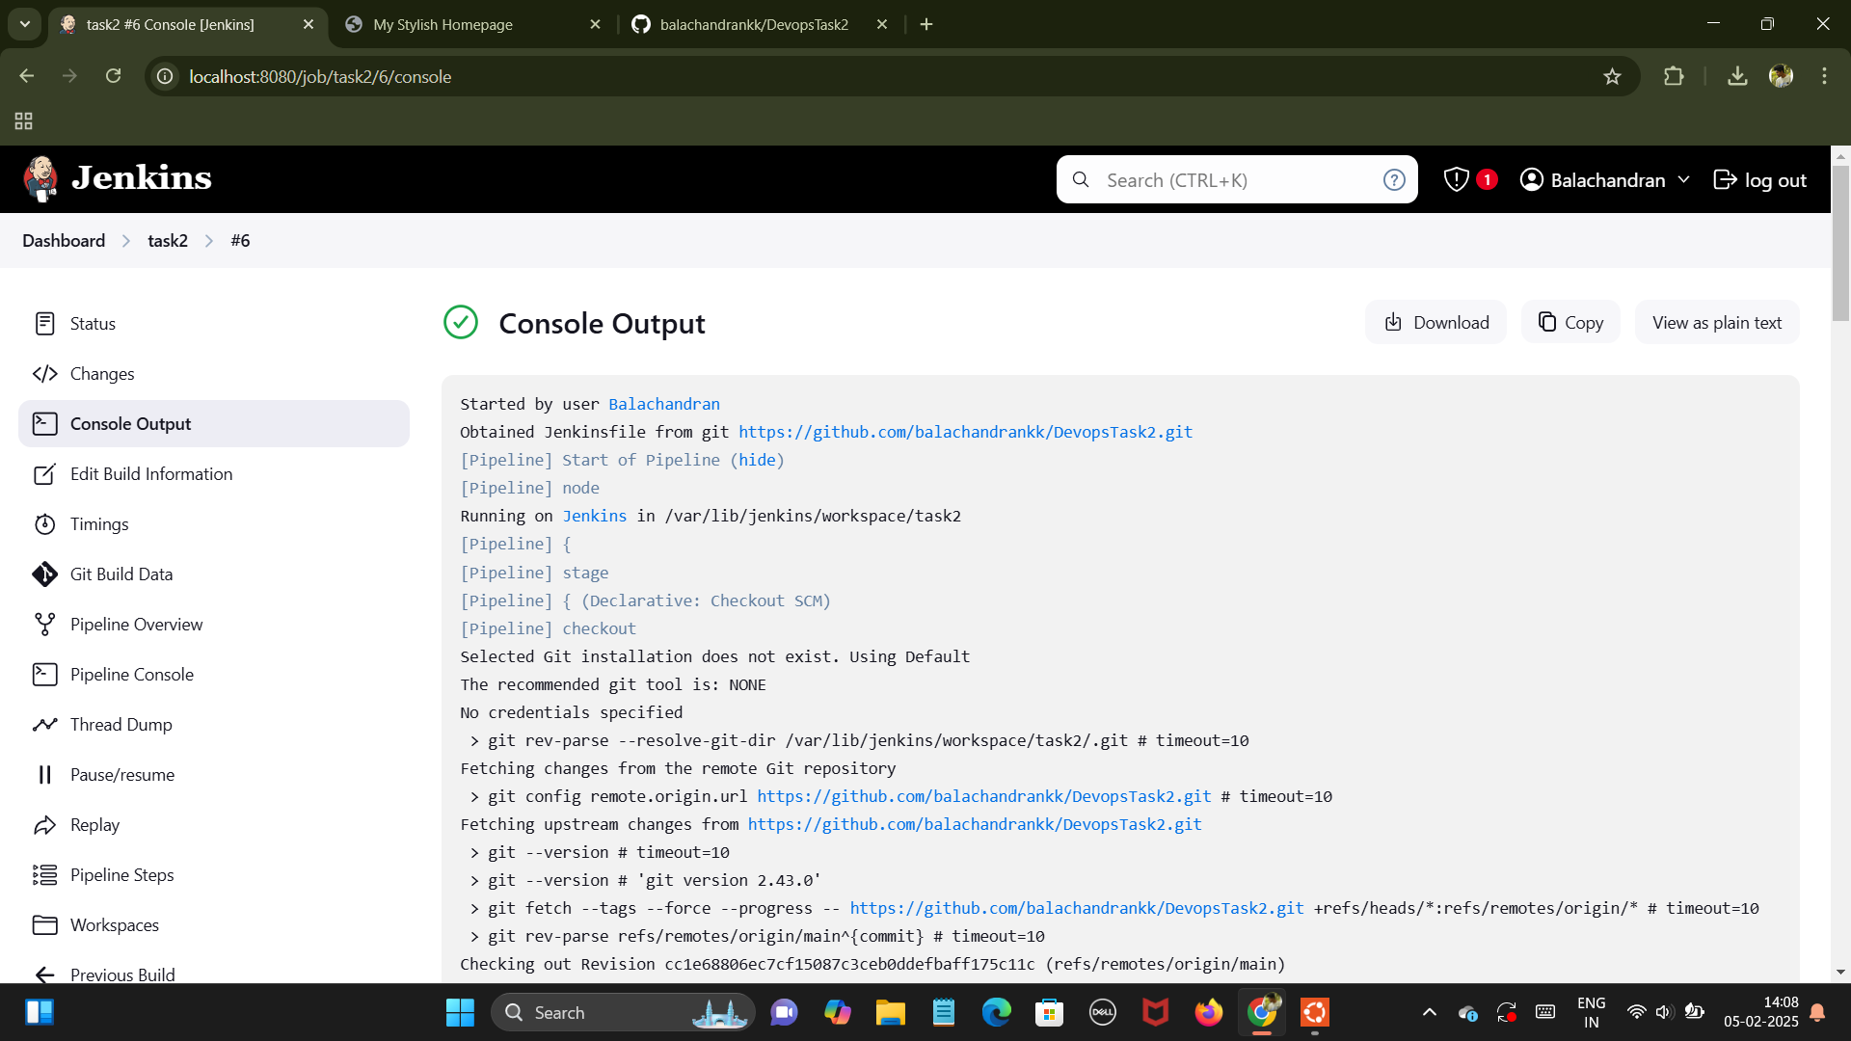

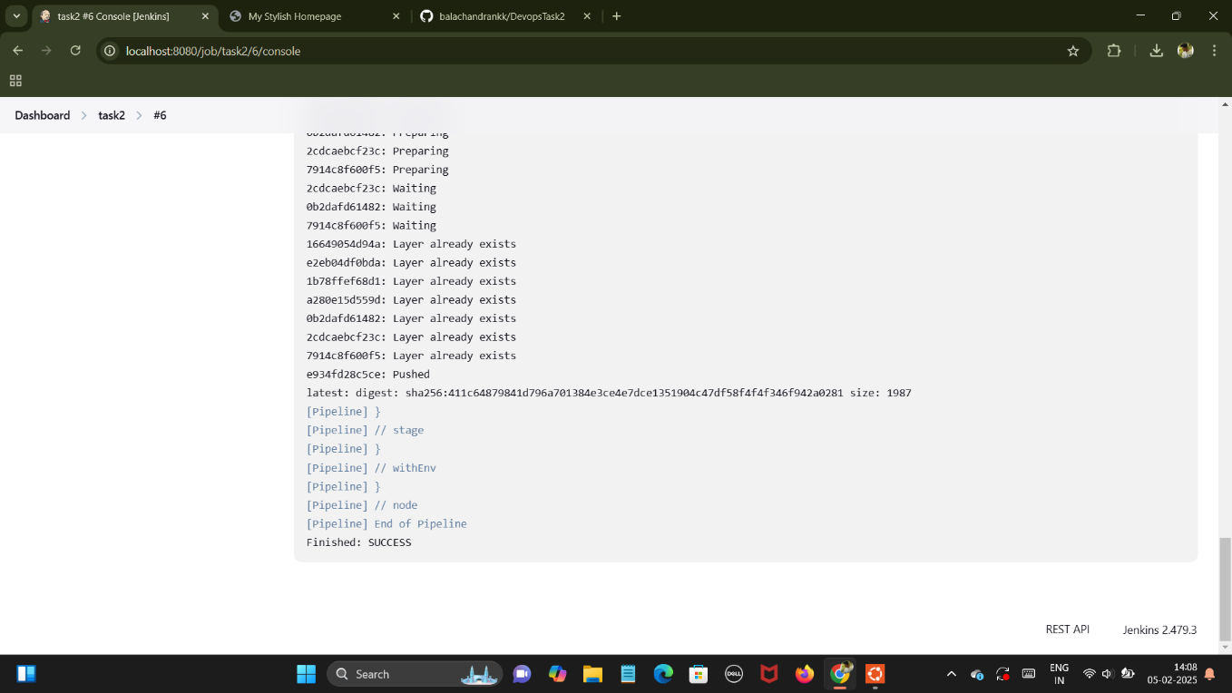

1. Final Output.

